MIDI-Variations Program

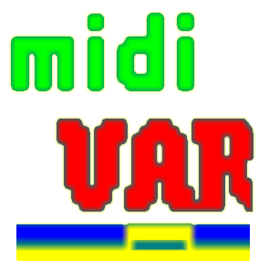

Program Description
(draft)
for Beta-Test-Version 6.0

Open a MIDI-file. Select a track. Press the VAR-button in the new dialog. Move the sliders an press the buttons. That’s it.

If you want to know more, read this manual:

midiVAR is a creative Tool

for composers and arrangers
If you have created a midi file for your song or composition just load it and vary some of the tracks. You will be astonished how much better it suddenly sounds because vivid elements are added to your piece. But you have to dose it very carefully. Too much variation will disturb the mood. An easy to use interface enables you to change the variation parameters in realtime and interactively as well.

Every creative musician faces the problem sooner or later that he or she is running out of ideas which would spark a new creative musical event. This program enables you to generate your own variations, which takes your style and your original ideas and then varies them in a manner which you have totally under your control, yet through its creative algorithms suggests new phrases and rhythms that unaided, you might not have thought of.

In addition you can select the pattern generator which provides a lot of never heard phrases and rhythmical patterns.

for Jazz musicians
For those musicians who are more interested in live sessions with other musicians, where the inspiration of the moment is the key to creativity, this program can support you. You can practice with it like with “Music Minus One” but due to the creative variation-algorithms, you will be con-stantly surprised and inspired to further melodic and rhythmical experi-ments by the new partnership the program offers. You also can be con-fronted with little errors as they may happen when you play with other musicians and then you can try to compensate them. As in real life but even better, because you can practice in this way for hours, without being afraid that the co-musicians get tired and run away.

With the Interactive-function you can change the Variation Parameters by your play, provided you play a midi-instrument. You also can write your played notes into a VTrack in real time. As for variations the note material is taken from VTrack and temporaryly inserted into an accom-painment-instrument track of your choice, you will get the impression that the program listens to you, because elements of your improvisation are taken up by another “musician”.

for parties
If you work as DJ with sequencers, this program can offer you much more than just to unreel your sequences. With a bunch of variation features you can pep up your music and make it more living and provide more variety and surprises, so that the dancers will all be saying "How does he or she do it!".

A Sample & Hold and an Arpeggiator section can provide an almost infinite number of looping or further developing patterns which can be varied on all tracks by all variation-features of this program according to your taste. Very nice for intros or as blocks between two sets.

for fans of Minimal Music
Music in the style of Philip Glass or Steve Reich is based on simple phrases which are repeated, shifted in time and varied. You now can create your own Minimal Music without the stress of writing down all the notes and practice it with real musicians.

This program enables you to automatically shift the beginning of track-patterns in time at each repetition and/or to shift the start-pointer for each track - even for a column! - by a step of your choice each cycle. The length of track-patterns can be different for each track. At each repetition you also can transpose and/or allocate another sound and/or switch off/on the pattern. This creates Canon-like scores which are very difficult to play by human beings. You would possibly end up in a psychiatric ward if you had to play for instance 120 permutations of the same phrase.

for creating automatic background music
If you combine the Arpeggiator and the variation-functions with the Transpose-Sequence, the MIDI-Channel-Sequence and the Switch-Off/On-Sequence features you can create easy listening background music that never repeats which also might be suitable for meditation.

for experiments
As you can overwrite your tracks (S&H and Arpeggiator as well) with the varied notes (press Improvisation-button), and as the variation para-meters of a track can be changed by the notes of this track interactively, you always will get new situations which will exceed all rules and conventions and your imagination.
What is different?

- The variations are created for each track in context of the existing note-material. Therefore, it is not necessary to enter harmonies, chord sequences or styles.

- In the most cases the variations sound as if they were played by a musician and not by an insensitive computer, due to the biolo-gical DNA-repair algorithm.

- The variations can be adjusted according to your own taste by interval spectra and Deltatime-factors and/or by using a complete different note material in the VTracks (see below).

- The VariationParameters can also be changed interactively by an external MIDI-instrument or by an existing track (which can be muted. It then serves as interactive control only).

- The varied notes can overwrite their own track, so that chaotic patterns, but also repeating bizarre patterns can be developed.

- The introduction of „Deltatimes“ (time between two MIDI-event-Ons of the same type) provides a big variety of group-editing features and new type of experiments.

- With each repetition a track can automatically be shifted in time, transposed, played with another sound and switched off/on and can begin at another position, and/or with another column-index by corresponding control sequences.

- The separation of MIDI-events (like notes, pitch-wheel, modulation etc.) into independent spreadsheets, where whole columns oder selected ranges can be edited, provides a new dimension to further experiments.

- There are some extraordinary editing features. For example, you can replace the key velocities of a certain note-number pattern by a squence of keyvelocities through the whole piece, etc…

How it´s done:

African music has provided the inspiration for this program. Listening to african rhythms it appears that the musicians keep on playing the same patterns over and over again. But this is an illusion. In reality they are modifying their patterns slightly and thus create unique living music in a form not seen elsewhere.
This program can automatically create patterns of melody and percussion which are constantly varied according to the parameters you set using simple graphical sliders. In this way we get warmer and more varied music than normal music generated by computers left to the mercies of a rigid program. The resulting music is not felt to be cold or machine-like – it has the human touch!.

The reason that this program has the human touch is that it uses an algorithm which emulates the DNA-repair mechanism in living cells. Hans Deyssenroth presented this algorithm for the first time at the Ars Electronica in 1983 . The special insight used by this program, is that in Nature, when both DNA-chains are broken by external influences, repair enzymes repair the damage by inser-ting a new sequence of molecular building blocks to make up the deficit. But, and this is the key to the harmonious results of this program – the new building blocks must fit into the sequence. In musical terms, this means that they must fit into the context of notes that are already there. Sometimes, as Darwin suggested, not every variation is successful. In our terms this means that not every musical variation is felt to be pleasing but, on the other hand, the variations created by this algorithm give a lot of new impulses for your creativity.

The “Nitty Gritty”
To produce suitable building blocks to supply the musical variations, an inverted copy of a sequencer track is stored into a separate Variation-Track (VTrack). The algorithm then fetches a sequence of notes selected at random from the VTrack (in forward or backward direction) to match the melody and rhythmical sequence, within the range of bars previously determined. It temporaryly inserts it into the track you have selected. At the next repetition the original pattern is available again and can be varied at another (or even at the same) position. The user interface provides two modes to change the variation parameters:
- Track: for the variation of notes of the track you are working on and
- VTrack: for the variation of notes from VTrack to be inserted (default)

(see Figures 1 and 2).

Variations Algorithm <Edit VParam>

7. these notes are temporaryly replaced by the selected notes from VTrack
Track 1

♪ ♫ ♪ ♪ ♪ ♪ ♪ ♫ ♪ ♪ ♪ ♪ ♪ ♪ ♪ ♫ ♫ ♫ ♪ ♪ ♪ ♪ ♪ ...
      Δt(tr)

1. set random position
e.g. on note ♪
condition:
6. Δt(tr) = Δt(vtr)

   

Variation Track 1 (VTrack)

2. search for ♪ in VTrack
Δt(vtr)
♪ ♪ ♪ ♪ ♫ ♫ ♪ ♪ ♪ ♪ ♪ ♪ ♪ ♫ ♪ ♫ ♫ ♪ ♪ ♪ ♪ ♪ ♪ ♫ ♪...

4. search  number of notes (random)
3. random position

5. found !

if not found

Figure 1

Samples for the user interface for settings and changes of some Variation Parameters. Figur 2:

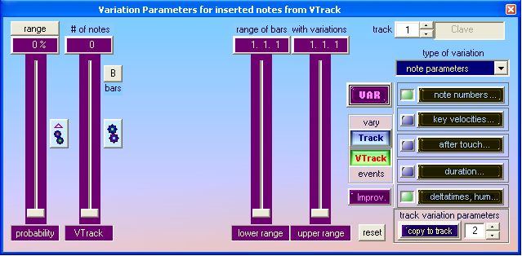

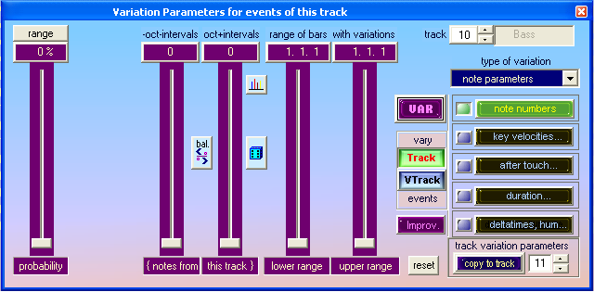

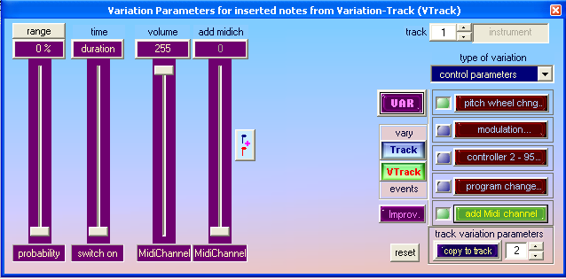
Try it !

Insert notes from VTrack into Track

The most important procedure for variations is inserting notes from the corres-ponding Variation-Track (VTrack) into the selected track according to the des-cription in figure 1. The Variations-Track is generated automatically, on setting a number of (maximum n) notes from VTrack with the slider „# of notes“ at <Edit VParam>. All tracks can be used for variations. All changes and selections can be done during the sequencer is running.

the button in this position causes the selection of a matching sequence of 1 to n notes from VTrack which is inserted into the selected track (searching the corresponding first note in VTrack). The inserted pattern temporaryly replaces the original pattern in the selected track.

the button in the pressed position causes that any random sequence of 1 to n notes from VTrack is temporaryly insertet into the selected track, without checking the matching condition. This setting is suitable for percussion instru-ments.

VTrack-notes and their properties can be edited and varied. In the status bar you see explanations of the operations that are done by buttons and sliders.

There is something new and it might be not easy to get used to it. These are the
Deltatimes wich are displayed in a column of the Event-Editor. It is the time difference from one stroken note to the next stroken note independend on how long the first note keeps pressed.

On On Off
♪---Deltatime---♪ ♪

Duration

Deltatime = time from Note-On to another Note-On
Duration = time from Note-On to the same Note-Off
Besides of notes, other MIDI-events (e.g. controllers) are displayed with these Deltatimes as well. Changes and variations can be realised very easyly by editing and modifying the Deltatimes.

Variation of VTrack-notes and Track-notes

There are two types of variations:

- The notes that are fetched from VTrack can be varied before they are temporaryly inserted into the corresponding track and replace the randomly selected notes there.

The Deltatimes can be multiplied by factors in order to e.g. halve the
On-to-On-times or to double them. The factors are selected according to the probabilities which can be displayed and changed via this button:
There are 4 spectra (profile numbers) with factors which can be allocated to various tracks.

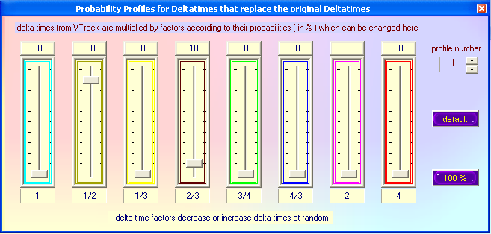

The NoteNumbers (corresponding to the keys of a MIDI-Keyboard ) can be changed by an “Interval-Spectrum“ .

By pressing this button the probabilities are displayed. Here it is possible to set the probability that a NoteNumber is increased or decreased by an interval. So it may happen that e.g. a C gets replaced by a G (fifth) with a probability of 20% or by a C one octave higher with a probability of 80%, provided the variation happens just on this C. The probability for that can be adjusted by the slider „probability“ at <note numbers> .

There are 8 spektra (profile numbers) with interval-probabilities which can be allocated to various tracks.
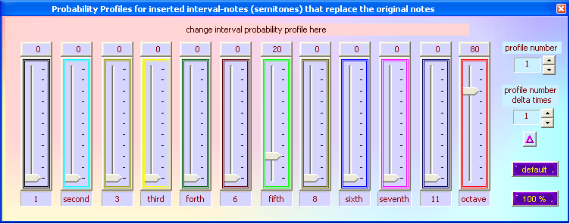

the button in this position causes that the variations of Deltatimes of the selected track are always compensated. The track is played synchro-nously with the other tracks. The rhythm is maintained.

the button in the pressed position causes that the variations of Deltatimes are not compensated. The track gets unpredictably out of control.

the button in this position causes that from several intervall-notes one note can be selected according to it’s probabilty in the interval-spectrum.

the button in the pressed position causes that only one or two notes can be selected which can be set by the corresponding sliders.
Besides of the common properties like Deltatimes, Durations, Note-Numbers and KeyVelocities (volume of note), it is possible to vary in addition the PitchWheel, Controllers and ProgramChanges. It is also pos-sible to add an additional MIDI-channel with a different sound just for one note.

- The notes of the selected track and their properties can be varied in the same way as in the VTrack-mode. The status bar shows the meaning of the buttons and sliders. The Deltatimes of track-notes yet cannot be changed by factors like the VTrack-notes, because the effect would be too dramatic and the „sense“ of the melody would get lost.

the button in this position causes that the Deltatimes are increased or decreased at random by small time intervals. By this method the human way of playing which is not so precise like a machine is emulated. It is recommended to apply this feature on quantisized tracks.

Some hints for Controller-Variations:

Pitch Bend:

the button in this position causes that the pitch-bend-variation may happen at random everywhere within the selected range of bars with each inserted VTrack-note in VTrack-mode, or with each note in Track-mode.

the button in the pressed position causes that the pitch-bend-variation happens only with one or maximum two notes which can be selected by the corresponding sliders.

Controller 2 – 95:

if the button is in this position the slider is used for selecting a Controller-number. The selected Controller is being switched on and of at random during playing.

the button in the pressed position enables the slider to adjust the rise times of the Controller.

The frequency of all variations can always be set by the „probability“– slider.

Add MIDI-Channel:

the button in this position causes that a note is played at random on an additional MIDI-channel. The effect is a sound-variation, e.g. the sound of a violin is added to the piano sound of the affected note.

the button in the pressed position causes that a note is played at random on another MIDI-channel. For instance: the original piano sound is replaced by a vibraphone sound.

„Improvisation“

Pressing the Improvisations-Buttons causes that the varied notes are written back to the track at each repetition. These notes can be changed again by the on-going variation process. By this, the varied melodie or pattern goes away from the original more and more. The VTrack is going to be changed too, so that the material for variations is different by time. Of course, this procedure cannot be compared with the creative process of an improvisator. Anyway, it is quite inte-resting to listen to this development and to change the Variation-Parameters or to improvise with these changing patterns interactively. By pressing the <Improv>-button, a copy of the actual situation is written into an undo-buffer. By pressing the <undo>-button the original situation is restored again.

Save Variations

By pressing the <Save Variat.>-button the same procedure as in Improvisation is performed, but only one time. After that, one can restore the original note or edit the varied notes until it sounds perfect.

Interactive Changes Of Variation-Parameters

When the sequencer is running the Variation-Parameters can be changed not only by sliders but also by incoming MIDI-events of a Keyboard or another MIDI-instrument connected to the MIDI-In Interface of the Computer. The
<Interact.>-button opens a dialog where one can select the event-type and the Variation-Parameters to be influenced. Instead of a MIDI-IN-source you also can select a track, to change the Variation-Parameters. If you mute this track it only serves as controller for this purpose.

There is also a feature that allows to store the played notes in the VTrack immediately. As the program fetches note sequences from VTrack and inserts them into the selected track (e.g. bass) one has the impression that the “bass player” is listening to the keyboard player because he is using the keyboarder’s ideas as well. The level of octaves is automatically adopted to the octave level of the affected instrument (e.g.bass). If the MIDI-channel 10 is selected - which is usually allocated to drums and percussion – the program uses only Deltatimes and not the NoteNumbers for variations. In this case the rhythmical ideas of the keyboarder are transferred e.g. to the bass.

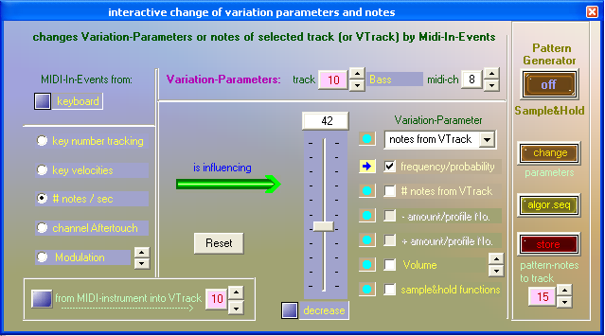

Sample & Hold / Arpeggiator

This function allows the creation of temperated or non-temperated patterns of scales where the the scale-steps and the borders can be varied. The borders can be automatically shifted with each repetition as well. The scales are based on the notes of a sequencer-track which can be varied as well of course. Using this feature, it is possible to create rhythmical patterns that extend farly everyone’s fantasy (set Midi-Channel to 10). The Arpeggiator-Function provides a huge variety of tonal patterns that can be changed by the sliders. There is a midi-file for one track that can be loaded as an example. All notes are the same (C) in the track.. These can be changed by editing, by activation of Variations and by storing the patterns into this track. which is the basis for the next pattern cycle.
If you select an empty track and switch on Sample & Hold, a track with 32 C-notes is generated. See more in Function 11.

Control by an external MIDI-Instrument

The sequencer can also be started and stopped, or tracks can be muted by an external MIDI-device which is connected to the MIDI-In-interface. It is also possible to adapt the sequencer-tempo to the tempo that is played live on stage by striking a specific note on the keyboard in the rhythm of half notes. The notes for these controls and the midi-channel can be selected in the corresponding dialog. You can mute or switch on again the first 8 tracks by a selectable note from an external keyboard. If you switch on the track by striking the corres-ponding key, the keyvelocity of this note is transferred to the main volume of this track.. So you can achieve dynamic live-performances.

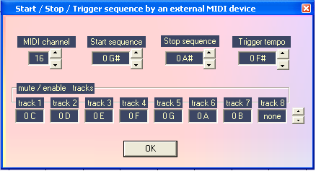

At your request it would be possible to activate other processes as well.

The MIDI-Event-Editor

In midiVAR the Midi-Events (notes, controllers, Sytem-Exclusive-messages and tempi etc. ) are organised as independend Spread-Sheets – which is different from other MIDI-programs - where the rows belong to the corresponding Deltatimes. This view makes it easier to experiment and to edit whole columns or ranges of columns. It is possible to edit almost everyting at running sequen-cer mode. The figures below show two examples, one for note-events and one for Pitch-Wheel-events:

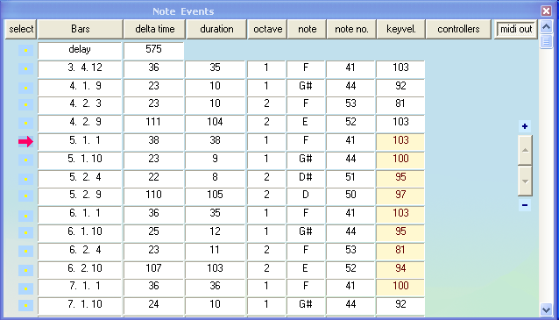
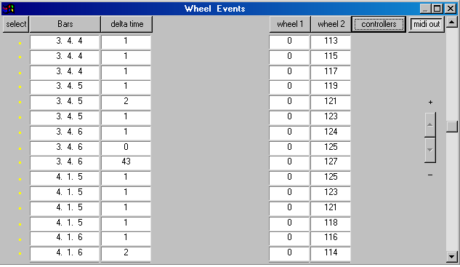
A click on a column-button in the Editor-Section selects either the values of the whole column or a previously selected range of a column (at the left side with the arrow by pressing the left mouse-button or with pressed Shift-Key and mouse-clicks on the rows or by editing the „from“ and „to“ fields at bottom right).

There are 15 Functions, to change data in groups. At some of them it should be obvious what they do, at some other functions an explanation may be necessary:

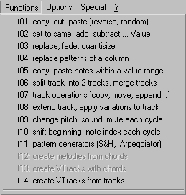
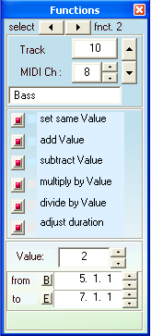
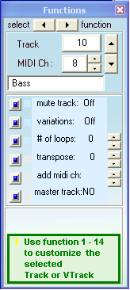
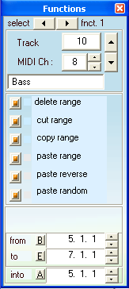

Function (0): “# of loops” means that the track stops playing after n loops. “add midi ch” means that the notes are played with an additional MIDI-channel to which another sound is allocated. “master track” means that all tracks start together with the Master-Track, if the Loop-button is pressed.
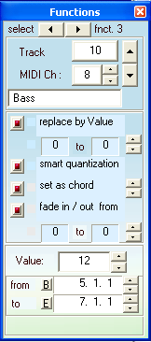
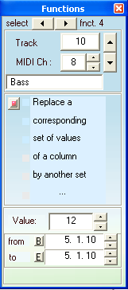
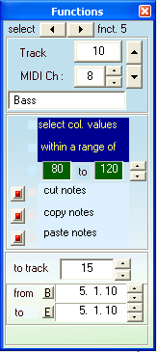

Function 2 enables you to e.g. multiply a colomn or a range of a column e.g. by 2. The Deltatimes-column as well, of course. “adjust durations” causes that each Duration is set to the corresponing value of Deltatime – 1.

Function 3 enables you to replace all values between e.g. 70 and 90 by the value of e.g. 12 (in the “Value”-field), if for instance the KeyVelocities are to loud. The smart quantisation calculates the correct notes according to the notes before and behind them. After quantisation the values e.g. 14, 21, 31, 33 are replaced by the values 12, 24, 32, 32. The value 32 is not divisible by 12 therefore, this seems to be wrong. But if there are some other values around of about 32 the program assumes that there are triplets (values divisible by 8or16). If this is not the case the values 31 and 33 are replaced by 36.
Another feature is to transform a pattern of notes into a chord or into an arpeggio (with the value of e.g. 12 in the “Value”-field).

With the “fade in / fade out“ feature it is possible to increase or decrease the values of a column or of a range of a column successively. Of course, this is true for the Deltatimes and Tempo columns as well (if one wants different tempi in a piece) or for Durations (if one wants that the notes are played shortly at first and then successively longer).

Function 4 enables you to transform a pattern of values of a column into a pattern of different values of another column. If, for instance, the rhythm with the Deltatimes 24, 48, 72 should be transformed into the rhythm with the Deltatimes 48, 24, 72 this can be done for the whole Deltatimes-column or in a smaller range of bars only. This works for NoteNumbers (e.g. percussion-instruments) as well, of course. Another example: If the KeyVelocities at the note-numbers 72, 77, 84 should be high then select at the row „change deltatimes“ the KeyVelocity-column and enter the values e.g. 124, 124, 127 below in the „change to“- field, and the corresponding notes are then played loudely.

Function 5 enables you to cut or copy rows of notes - for which the values of a column, like KeyVelocities or Deltatimes are within a range of values - and to paste them into another track. The selection can occur within the whole column or within a range of bars (from, to). By taking out some notes the rhythmical lack of Deltatimes is compensated. The pasted notes in the other track are rhyth-mically at the same position as before in the source-track.

Function 6 enables you to split a track into two tracks at a selected Note- Number e.g. 60. The notes with the note numbers smaller than 60 remain in the first track. The other notes are copied to another track at the same rhythmical position.
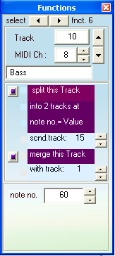
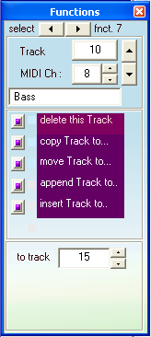
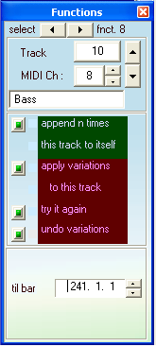
Function 7 shows a facility for track operations. Append and Insert is possible for the the own track and for another track as well.

Function 8 enables you to extend the active track by appending it to itself so often until the length of the extended track achieves or exceeds the selected bar in the field “til bar”.

With the second button it is possible to overwrite this track by itself plus variations according to the settings of the Variation-Parameters. If you don’t like the result you can try again until you can accept it. For the case that there are still some minor details that do not match your taste, you can correct this by the Event-Editor.
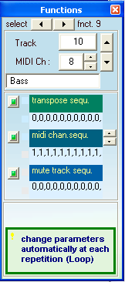
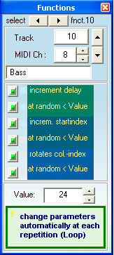
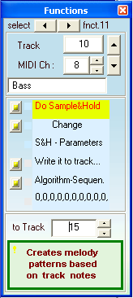

Function 9 enables you to transpose the pattern of a track at each repetition (if the Loop-button is pressed) by a value set in the “Transpose-Sequence”-field. If the Transpose-Sequence-button is pressed the track-notes are transposed according to the sequence of e.g. <0, 4, 2, 5, 3, 7> from e.g. C to E to D to F to Eb to G and then again from the beginning to C. The temporaryly inserted notes from VTrack are transposed as well.

Another feature is to change the MIDI-channel at each repetition according to the MIDI-channel-sequence. If the “MIDI-Channel-Sequence”-button is pressed there is another sound each cycle belonging to the corresponding MIDI-channel.
Instead of MIDI-channels you can select ProgramNumbers as well, to which specific instruments are allocated. This setting might be useful for sound-cards whereas the MIDI-Channel-Sequence might be more useful for external MIDI-modules.

Finally it is possible to mute a track during a cycle according to the “Mute-Sequence” pattern. If the corresponding button is pressed the track is muted at the pattern-value 1 and activated at the pattern-value 0.

Function 10 enables you – provided the Loop-button is pressed – to shift in time the beginning of the selected track by a Deltatime set in the field “Value”, at each repetition.

Another feature is to start the track at the first repetition not on the first note as before but on the second note of the track (Value = 1) and on the third note next cycle etc., or on a note that has a distance of e.g. Value = 3 from the previous start-note at each repetition.

A crazy feature is to rotate the index of a selected column at each repetition by the value of “Value”. That means that the track begins with its first note but the note-number comes from another row (index), if you selected the note-number-column. You can force this operation without waiting for the next repetition by pressing the switch-button for this feature several times.

Function 11 enables you to create rhythm- and melody-patterns

There are two modes:

a Sample & Hold mode, to create atonal patterns and

an Arpeggiator mode to create patterns based on chords

If you switch on the Sample & Hold and the selected track is empty, a track with 32 notes of C (note-number = 60) is created. The development of patterns is based on these track notes, which can be edited and varied by all the Variation features and stored back to it’s own track.. The Sample & Hold feature provides patterns based on scales. Each pattern note is the sum of the track-note plus the step of the scale. The Arpeggiator provides patterns based on chords which can be defined by intervals to the base note (the base note is the actual track-note). The borders and a stepwise movement of the borders at repetition can be adjusted to your requirements. In addition there are features for Portamento and fixed Pitch-Wheel positions. If you change the speed, the Deltatimes of the selected track are changed. It doesn’t influence the tempo of the piece. So you can synchronise the patterns with the other tracks either fitting or shifted. With the “algorithm”-slider you can set a suitable function for moving up or/and down the pattern-notes. There is also a random and a pemutation algorithm.

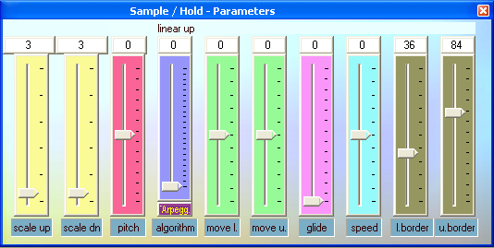
The same features are in the “Interactive”–Dialog (press the <Interactive>-button in the Toolbar).

Function 12 enables you to generate melodies based on a sequence of chords.
This has not been programmed yet but will come with the next version.

Function 13 enables you to create a Varation-Track (VTrack) based on a sequence of chords. This has not been programmed yet but will come with the next version.
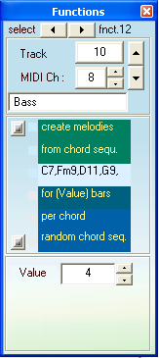
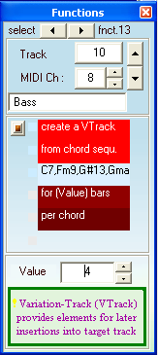
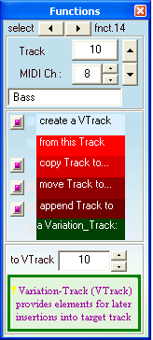
Function 14 enables you to create Variation-Tracks (VTracks) from other tracks and to do the normal track operations with them. Usually the VTrack is created automatically as soon you move the slider “# of notes” in Variation-Parameters-Dialog with pressed “VTrack”-button.

For the Variation-Tracks (VTracks) the Functions 1 – 7 work as well.

The Track – Editor
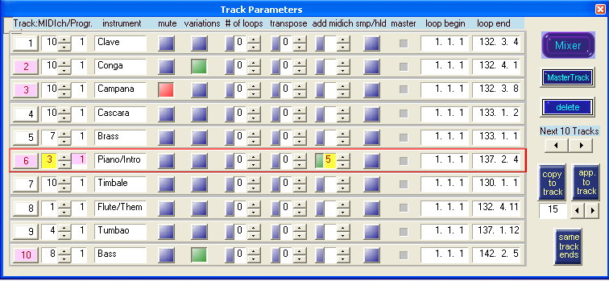

In the Track-Editor you can set and change all important properties of a track.. If you select a track, this track is active in the other Editors and Dialogs as well.

With the button “same track ends” you can set all tracks to the same lengths. In this situation, all tracks begin together if a new cycle starts. Usually each track has it’s own cycle time. If the note-pointer comes to the end of the track it starts from beginning with or without delay (default). This can be set with the Loop-button. The other features are described in section Function (0).

The Controller-Mixer

From the above dialog – or from menu under View – you can activate the Controller-Mixer. For example the main volumes of tracks can be changed here and recorded and played at running sequencer. If the track is long enough, it is possible to transfer the track-volume settings to the key velocities. The track-volume is a MIDI-Controller-event and therfore, it is inserted into the Controller-Spreadsheet.

Besides of the track-volume, there are 23 other controllers (like Pan, Breath-Control, or Pedals, or intenisites of Effects) which can be recorded (mixed to the other ones, or removed) and played in the same way. In this case the sliders are moving and show the position of the selected controllers with time.

A Controller can also be connected to PitchBend, AfterTouch and to Program-Change directly or it can be recorded (or removed) to the corresponding Spread-sheet.

In addition, a Controller can be connected to a column of the Notes-Spreadsheet (KeyVelocities, NoteNumbers, Durations, Deltatimes) either directly, or it can be recorded at running sequencer. The differences from the middle slider position (64) are then added to the values of the selected column.

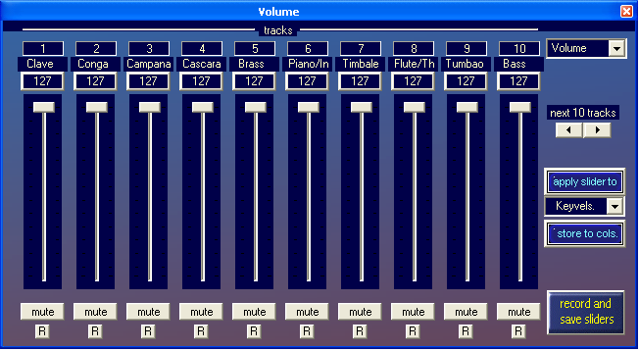

This opens a new dimesion for changing all possible MIDI-events.

There is also a Tempo-Spreadsheet, where tempo and signature settings can be changed. You can record tempo and signature changes at running sequencer. Switch on the record button at left from tempo edit field.

The View

With transport bar:

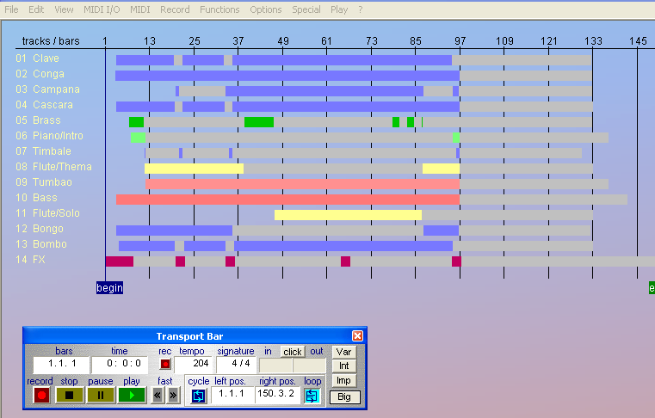

There are three types of loop-funktions: one is called „Cycle“ which switches on a continous repetition between begin-locator and end-locator. The second one switches on the individual repetition of each track.. If the track lengths differ from each other there can happen interesting superpositions ( is set to default). The third one is the setting of a number of n(track) loops. After n repetitions the corresponding track stops playing (see < Edit Tracks> oder Function 0).

Instead of Stop and Pause there are two buttons with „Start“ from beginning and „Continue“, which continues from the stopped location.

The above mentioned functions cannot be realized with a tape machine, but for the computer it’s no problem.

With big transport buttons and comfortable locator dialog elements:

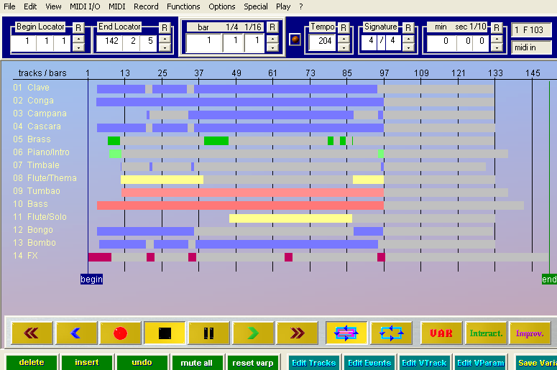

If you move the mouse pointer over the bars you can select a track. If you click on a bar with the left mouse button, the dialog appears where you can change the Variation-Parameters. With the right mouse button or with double click you can open the Event-Editor.

The start- und end-tags can be moved. In this case the piece loops whithin those boarders.

If you press the Start-Button, a display appears that can be changed in color and size (mouse pointer to the corner at bottom right). You can see either the played bars or the played time in minutes, seconds. If it disturbes you can switch it off.

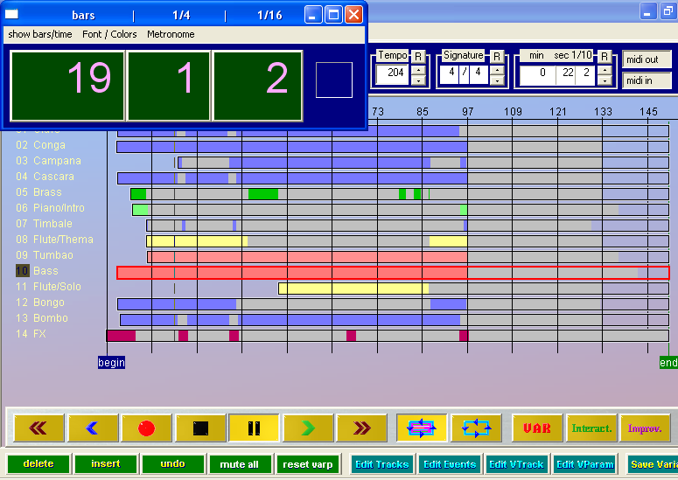

In the Menu you find some more features.

To be continued …

